NewLoop
A model of the AI Economic Transition
Roger Ison, roger@miximum.info

Abstract
NewLoop is a stock-flow-consistent macroeconomic simulation of an economy transitioning toward advanced, machine-intelligence driven automation. This document explains the model’s conceptual policy layer (taxes, transfers, social ownership rules, and automatic stabilizers) and describes each mechanism in plain terms so non-modelers can understand what institutional choices are being assumed.
The core policy package includes:
- a Social Wealth Trust (FUND) that accumulates equity ownership over time (with an explicit cap);
- a Universal Basic Income (UBI) computed to maintain a baseline real-income pool and constrained by a ratchet (non-decreasing);
- a value-added tax (VAT) paired with a targeted low-income VAT credit (prebate);
- a marginal income tax above a percentile-defined cutoff (with UBI excluded from the income-tax base); and
- a corporate income tax that can automatically rise as wages fall during the automation transition.
- policies to adapt existing fixed-nominal debt, specifically mortgages, to a deflationary environment.

Introduction
The sudden, rapid diffusion of advanced artificial intelligence through the economy will create crises and opportunities unlike any prior event in human history. Huge efforts are presently expended on concerns such as "alignment" and "safety," which certainly are things that matter. But the most urgent questions, which will shape real lives at scale, are economic: what happens to incomes, purchasing power, investment, and social stability when automation spreads through most forms of work? Despite its urgency, this subject is only beginning to receive the attention it deserves.
Historically, the revenues earned from economic activity are split among labor, capital, and government. In plain terms: consumers buy goods and services; businesses use that revenue to pay workers, pay taxes, and generate profits; workers then spend and save; owners invest and consume out of profits; and the cycle continues. This is capitalism: a circular feedback system that stays in balance because the ability to produce is meaningless without the ability to buy. Wages are not the only source of purchasing power - people can also consume out of dividends, transfers, credit, and asset income - but the system must reliably generate broad, spendable income at the scale required to clear the economy’s output. We call this circulation the “Old Loop”.
The consequences can be severe and persistent when that loop fails. Collapsing demand propagates into collapsing production: falling sales lead to layoffs and cutbacks; layoffs reduce incomes; reduced incomes further reduce sales; investment stops; and productive capacity can be impaired for years. The Great Depression was a feedback failure so profound that even extraordinary policy efforts struggled to restore normal economic activity. My grandfather, a railroad fireman, was out of work for a decade. He traded a solid gold railroad watch for a milk cow to plow the garden and feed the family. Whatever one emphasizes as proximate causes, the durable lesson is that restart can be difficult once the link between output and purchasing power is damaged, and the consequences can spill into conflict and politics for generations.
Economically, advanced artificial intelligence is an unusually powerful form of automation. It will automate information and intellectual work first. As that proceeds, it will somewhat later also accelerate automation in physical systems, mining, manufacturing, logistics, agriculture, construction, and beyond. Automation raises productivity and lowers operating costs. But it also changes the income architecture of the economy: as software and machines substitute for labor, a smaller fraction of value added shows up as wages and a larger fraction shows up as profits and returns to capital. If ownership of that capital is concentrated, then purchasing power becomes concentrated too, even while productive capacity expands.
Corporations are the engines of modern wealth creation. Only large-scale enterprises can reliably perform research and development, design, logistics, manufacturing, marketing, distribution, and global support for complex products and services. So the issue is not to stop progress, nor to replace productive enterprise with circular services in which we merely transact among ourselves. The issue is how the feedback loop that connects production to purchasing power can remain stable as labor income shrinks, so that wealth creation can continue.
That’s the core conundrum. If wages stop being the dominant channel by which most households receive income, where does broad purchasing power come from? If we want a prosperous society that continues to invent, build, and improve while much of the operational work is automated, then we will have to redesign parts of the income-and-ownership system, not just "patch" it.
This is not fundamentally a left-right political argument. It’s a systems-engineering problem in the design of a modern economy. The timing of change is uncertain; the direction is not. And the failure modes are reasonably clear.
One failure mode is a concentration trap: the rents from automation accrue to narrow ownership, purchasing power becomes too concentrated, demand weakens relative to capacity, and the system’s social legitimacy erodes. Another is a treadmill trap: we attempt to offset structurally declining labor income with ad hoc transfers and stimulus without changing the underlying architecture, producing fiscal strain and political fragility without restoring a durable, self-supporting loop.
There are plausible ways forward. They likely involve some combination of broadened ownership, redesigned tax bases suited to an economy where labor income is no longer central, and income mechanisms that are less tightly coupled to employment. But proposals should be judged by concrete criteria: do they keep aggregate demand sufficient to clear output, preserve incentives for investment and innovation, avoid unstable debt expansion, and remain politically sustainable over decades rather than election cycles?
This is where computational modeling becomes essential. When a system is governed by feedback, delays, and nonlinear effects, verbal reasoning breaks down quickly and ideology fills the vacuum. Models are always wrong in some way, but a good model can be inspected and argued. You can see exactly where income comes from, where it goes, how investment is financed, what happens as wages decline, and which policies move the system toward stability versus crisis. You can identify failure modes - and, just as importantly, you can locate the policy regions where the system becomes self-supporting again.
So what follows is an explicit economic transition model: a stock-flow representation of 20,000 “households” whose wealth, income, revolving debt and mortgages roughly correspond to the distributions of families in the United States. It includes firms, banks, and government as aggregate players. In this model economy, automation causes over time a rising substitution of capital and software for labor, shifting value-added from wages toward profits over time.
The model is designed to explore a central question that is simple to state, but hard to solve: what ownership and policy architectures keep aggregate demand, investment incentives, and social stability inside a viable region as automation advances?

The model tells a story
This transition will not arrive as a single shock. It will spread unevenly across sectors, punctuated by surprises, and accelerated by feedback. So the model tells a story.
Early on, call it the “first wave,” not a year on a calendar, machine intelligence stops being scarce. It becomes a commodity input: embedded in software, wrapped into workflows, and eventually integrated into physical systems. Then the decisive issue is no longer whether automation is possible, but how quickly it diffuses, and what it does to the economy’s income architecture.
The first visible break is in information work, not because the work disappears, but because the same output can be produced with far fewer people. Accounting and compliance become “continuous” rather than seasonal. Routine analysis compresses into automated pipelines. You still see humans in the loop, but the loop is narrower than expected and narrowing further. Productivity rises, headcount stops rising, and then quietly falls.
A partner at a large professional firm says it plainly at an industry dinner: “We used to sell hours. Now we sell outcomes. And outcomes don’t need headcount.”
Automation of the physical economy follows, slower at first, then faster. Early robotics is specialized: systems designed for narrow tasks. But the direction of travel is toward generality, toward machines that can be retrained and redeployed, because the bottleneck is no longer the actuator but the cognition that coordinates perception, planning, and control. Automation creeps into warehousing, manufacturing, mining, agriculture, construction, maintenance, logistic, and then into the parts of those domains that used to be protected by “situational complexity.”
By the “second wave,” firms begin to treat hiring as the expensive, irreversible decision. Managers defer hiring even when business is strong, because the option value of automation is rising. Displaced workers often find work, but less often find work that pays like the jobs that disappeared. Wage growth softens, then the wage share begins to slide.
At the same time, capital demand rises. Automation is not free. Even when cognition becomes cheap, building the intelligent equipment and software infrastructure needs up-front investments in hardware, sensors, integration, robotics, data pipelines, security, and the organizational work of changing how production is done. And because the advantage is competitive, speed matters. Firms borrow to transform. Banks and markets accommodate, until they start to notice that the same technologies raising productivity are also reshaping purchasing power.
Now the story becomes macroeconomic.
A strange squeeze develops. Households attempt to maintain consumption while labor income weakens. Some draw down savings. Some borrow. Revolving credit expands in the places you would expect: the middle and lower middle, where a loss of hours or wages is not a “temporary inconvenience” but a balance-sheet event. Firms borrow to finance automation investment. The economy’s ability to produce improves, but the economy’s ability to pay for what it produces starts to weaken and will collapse unless something replaces wage-linked purchasing power at scale.
Prices respond to opposing forces. Productivity and competition push prices down, especially in tradable sectors. But markup capture can push the other way, especially in concentrated markets or where switching costs are high. The model does not assume a single outcome. It lets pass-through and capture contend, because the policy regime must survive either a deflationary transition, an inflationary one, or a mixed reality.
Either way, debt service becomes the fragility channel. If the regime tilts deflationary, nominal incomes soften while nominal debts remain fixed. If it tilts inflationary, households face higher consumer prices while wages lag. In both cases, the upper tail cracks first. The warning sign is not the average household; it is the ninety-fifth percentile of debt-service pain. Lenders begin to see a pattern: this is not a normal cycle, and not a one-time shock. It is structural. It is the automation transition.
A bank risk officer puts it in a sentence that makes the room go quiet: “The collateral is fine. The borrowers aren’t. And it’s not because they’re irresponsible—it’s because the income architecture is changing.”
Then comes the recognition moment. Credit tightens where it most hurts demand, and the economy becomes demand-constrained even while productive capacity is growing. The system can still produce, but fewer people can buy.
This is where the model begins: not at the start of automation, but at the point where the feedback loop between output and purchasing power starts to break.
The design problem is now explicit. If wages are no longer the dominant channel by which households receive income, what can replace the cash flow that supports mass consumption and social stability, without destroying incentives to invest and innovate?
The model’s answer is not a single lever. It is an architecture: a set of rule-based stabilizers that shift purchasing power and ownership in ways that can scale with automation.
The first move is to broaden ownership of productive assets gradually, credibly, and with a hard cap. The model introduces a Social Wealth Trust: a trust fund held on behalf of citizens, not an operating arm of government. Its purpose is not to run companies; it’s to accumulate equity ownership and distribute part of the resulting returns. The trust activates only when measurable stress crosses a threshold, so it behaves like an automatic stabilizer rather than a permanently expanding institution.
When the trigger condition is met, the trust can be kick-started with bank-created credit. The bank lends to the trust; the trust purchases a slice of outstanding equity; households receive the cash proceeds; and the trust repays the loan over time. That launch mechanism matters because it accelerates broad ownership without requiring an immediate tax grab or a politically fragile appropriation.
But the core of the ownership transition is not the launch. It is the ongoing mechanism: what the model treats as a form of equity-dilution tax that is implemented as new share issuance allocated to the trust until an explicit cap is reached.
The obvious question is: why would corporations accept that?
They accept it in this story for the same reason they accept many things that look costly in isolation: because the alternative is worse, and because the rule can be made predictable, limited, and compatible with capitalist incentives.
A CEO of an automation-heavy manufacturer says it bluntly in an earnings call, after an analyst presses on “why tolerate dilution at all?”: “We can build capacity faster than the economy can absorb it. Customers don’t come from spreadsheets. If broad purchasing power collapses, we’re not ‘more efficient’. We’re stuck with stranded capability. A stable rule we can price is better than a political firestorm we can’t.”
That is the hard constraint: in a mature automation transition, the binding constraint is not productive capacity. It is demand. Firms cannot monetize productivity if the consumer base is insolvent or purchasing power is too concentrated. The dilution rule is framed as a demand-preservation instrument: it converts a fraction of the automation dividend into distributed purchasing power without requiring firms to raise wages for jobs that no longer exist.
A CFO phrases the acceptance logic in the language markets understand: “If it’s universal, capped, and rule-based, it’s not ‘expropriation’, it’s a cost of doing business in a high-automation economy, like a tax, like regulatory compliance, like stock-based compensation. The market can price it. What markets can’t price is unpredictable backlash.”
That predictability is central. A small, stable, widely applied dilution rate is something investors can incorporate into valuation. It reduces the risk premium associated with tail events: windfall confiscation, arbitrary sector-specific punishments, or emergency interventions that arrive precisely when credit is already tight. A rule-based mechanism is not “free,” but managers can read and understand it, and legibility lowers the probability of chaotic, discretionary policy.
A portfolio manager adds the quieter point capital markets rarely say out loud: “The real threat to returns isn’t a few basis points of annual dilution. It’s the social legitimacy gap. If the system stops working for most people, the political system will eventually reach for something much cruder.”
The mechanism is also framed as a substitute for more distortionary tools. As labor income becomes less central, the tax base must shift. Governments will come after profits, consumption, wealth, or all three. In that political reality, a capped dilution mechanism can be presented as growth-compatible: it is gradual; it doesn’t depend on brittle enforcement against profit-shifting; and it builds broad claims on capital without requiring repeated political battles over explicit confiscation.
The cap matters here. The trust is not allowed to become an unlimited accumulator of control. The policy goal is to create a stabilizing ownership share, not to nationalize the corporate sector. The cap makes the mechanism credible to founders, boards, and long-horizon investors: it ensures the rule does not converge toward takeover. And the trust’s role is structured as passive ownership in economic intent: broad claims on returns, not politicized management. Firms accept dilution more readily if they can believe the trust is not a steering committee.
Under those conditions, the equity-dilution rule reads less like punishment and more like a premium paid for macroeconomic stability and continued license to operate in a society where labor’s role in income formation is shrinking. It’s a structured way for firms to buy what they need: solvent consumers, political legitimacy, and a predictable policy environment in which long-term investment remains rational.
The trust fund accomplishes another important goal: it addresses the duration-matching requirements of citizens’ income funding needs over normal human lifecycles. In today’s world, people are born without assets, although they may inherit some wealth eventually. When families are young, they need money raise children, fund college educations, buy a house. These large financial demands get in the way of saving. Students in college need income support. And in old age we have Social Security, but its implementation in some ways a pyramid scheme built on the idea that the young finance will the old. None of this works in an aging, deflating economy. The trust fund is a national endowment, a property trust owned by the citizens themselves, with a perpetual horizon.
The second pillar in the story is a broad consumption tax, modeled as a VAT wedge between producer and consumer prices, paired with a targeted low-income credit (“prebate”) so the tax does not function as a regressive demand-killer. A VAT is attractive in this world because it scales with consumption in an economy where wages are no longer the primary taxable flow, and because it can be enforced more reliably than an ever-more-complex wage-tax system. The model does however include an income tax (flat rate on wages above a minimum income), and an indexed corporate tax that rises somewhat as wages fall.
The third pillar is Universal Basic Income, defined in a way that matches the systems-engineering problem. In the model, UBI is computed to fill the gap between market incomes and a baseline real-income pool. It is indexed to the price level, so it stabilizes purchasing power rather than merely moving nominal transfers around. And it has a ratchet: once it rises, it does not fall. That is a realistic political assumption as much as an economic rule: benefits that can be withdrawn easily are not a stable foundation for an economy undergoing structural labor displacement.
Funding is handled as a hierarchy rather than a slogan: some share can be financed by monetary issuance; then trust balance contributes; then government balance contributes; with issuance as the final backstop. The model is not asserting that issuance is consequence-free. It is making the backstop explicit so the model can test how much is required, when it is required, and what happens if it is used too aggressively.
These mechanisms work together to support one existential objective: keep the economy operating in a viable region as automation advances. They are not asserted as the answer. They are parameterized rules whose job is to preserve the feedback loop that makes a modern economy function: production, incomes, consumption, investment, and social legitimacy.
If this story is right, the payoff is enormous. The automation transition fades from emergency into baseline. Productivity gains show up as rising real living standards rather than as a collapse in employment-linked income. The economy continues to invest, invent, and build, because consumers remain solvent and demand remains sufficient to clear output.
Even if the story is wrong, the model is still useful because it makes the failure modes visible. You can see where the loop breaks, which instrument fails first, and what kind of adjustment might restore stability.

Escaping the Fisher Deflation Trap

Same storm, different ships
The hardest part of adapting to intelligent automation is that while the old political and economic rules and reflexes no longer work, each Great Power or region was compelled to make its own mistakes. Old habits are hard to break.
The storm hit everyone, but the ships’ hulls were built differently. China had the engines: manufacturing scale, engineers, and command capacity. It also had a balance sheet that deflation could crack like ice. The United States had the laboratories and the venture capital, but not the steering wheel. Its politics could argue for years about who deserved the gains even as the gains arrived on schedule. Europe had the deepest social contract and an instinct to keep people whole, but it paid for that with speed and coordination.
And then there was the rest of the world, the places that did not invent these machines but could purchase them. In theory, that meant they could compress history: import the tools, skip intermediate stages, and become consumer societies faster than the old powers ever could. In practice, it depended on who owned the machines, who collected the rents, and whether new productivity was converted into household purchasing power rather than exported upward and outward. The same technology that could build a middle class in ten years could also hollow one out in five.

China
China entered the AI era with the world’s greatest manufacturing base, a deep bench of engineers, and a state apparatus that can concentrate astonishing resources. But as the first hump arrived, the early hit from automation to information-sector wages and early-career employment, Chinese youth unemployment was already in the high teens. China also carried an enormous debt stack, especially tied to property, much of it fixed nominal. In a deflationary environment, that is balance-sheet poison.
Land-transfer income and property-linked revenues had been a core funding channel for local government, most acutely at the prefecture, county, and city level, and that channel had been shrinking for years. In a deflationary regime, the local fiscal model and the debt model fail together.
Meanwhile, China’s domestic consumer economy remained comparatively underdeveloped, so exports still played an outsized stabilizing role. Yet across the developed world, re-industrialization increasingly meant automation and capital deepening, not a wage boom, and therefore not an expanding consumer base for imported goods.
Beijing tried to redirect exports toward faster-growing regions, but ran into strategic pushback and geopolitical friction, especially in the Americas. And with weaker domestic consumption, “tax the consumer to keep the macro pump primed” had less leverage than it did in economies where consumption is the dominant engine.
Then there was Taiwan: smaller, wealthier and institutionally more flexible, and the owner of the most strategically indispensable export category of all, semiconductors, the brains of AI machines. Beijing couldn’t ignore the risk that a widening performance gap between Taiwan and the Mainland might become a legitimacy problem at home. But forceful unification risked a severe U.S. reaction. Waiting for American semiconductor self-sufficiency might reduce that risk, yet the diffusion speed of AI into the knowledge economy compressed the timeline.
Also, taking Taiwan Semiconductor Manufacturing Corporation and Taiwan’s entire semiconductor industry offline might offer another possible advantage: it could delay global AI industry progress while giving China a chance to catch up with ASML and TSMC in semiconductor manufacturing technology. Yet that devilish gamble would leave a clear field for Korean and American companies, and it might be a long, long time until the world would forgive and forget. The costs to China itself could easily add up to trillions of dollars.
There was no clean solution, only choices trading one kind of instability for another. Ultimately, China’s limited internal flexibility got in the way of transforming itself quickly. It could push forward most effectively by continuing to do what it already knew how to do. Xi Jinping had intended his timeline to be shaped by age, career, and succession, by the need to hand a unified China to the next leader. But events moved too fast. Internally, the system was simply not yet ready for its citizens to be wealthy without being occupied by hard work, and the risks of military force against Taiwan were too great.
Of course, the Chinese were endlessly clever about applying AI in their economy and their systems of political control. But with so much still depending on exports, China softened its image and adjusted its outward posture, not out of conversion but necessity. It refocused its export machine on products that helped regional neighbors in Asia and partners across Africa modernize faster. Those customers needed electric power equipment, networks, transport, and factory automation. These targets would give China a second chance in the coming global cycle of physical-sector automation, but it felt like a bitter second prize.

United States
America sailed into the storm from the opposite direction. It had the laboratories, venture capital, software talent, and cultural permission to move fast and break things. It could turn ideas into companies faster than anyone else. That was its superpower and its trap. The gains arrived first as private property, not as public design.
When automation began to compress wages beyond a few industries, the old postures and arguments awoke on cue. Conservatives insisted that displaced workers would simply find new jobs, as if history were a law of physics. Progressives wanted the winners to pay, as if punishment could substitute for a working economic engine. Neither side would admit what the numbers showed: in a mature, automated economy, labor could no longer be the primary conduit carrying purchasing power to households at scale.
Washington tried the familiar compromises of the late twentieth century. Borrow through the transition. Stimulate on the way down, patch on the way up. Argue about taxing wealth. Squeeze health care. But the leak was structural, so patchwork could not hold. When wage income stops rising, household balance sheets stop rising with it. And when households stop rising, the collateral behind the entire credit system begins to soften.
The Federal Reserve understood deflation, but it could not cut interest rates below the basic fact of missing cash flow. Monetary policy could change the price of short-term credit, but it could not guarantee the incomes that made credit safe. The stress appeared where it often does in America, first in revolving debt, then in housing, where the middle class is levered. Mortgages began failing in ways that did not look like the last crisis, and housing prices began to fall, trapping families in homes they could not afford. The payment shocks were not driven by teaser rates or exotic underwriting. They came from ordinary families whose work had been made cheaper than their debt, if not eliminated.
As the mortgage markets creaked and groaned, the problem revealed its second face. Corporate credit began to wobble too. If consumers cannot buy, revenues cannot hold. If revenues cannot hold, debt cannot roll forever. The storm that began in software reached the balance sheets of the physical economy.
Only then did the argument change. It stopped being a fight about fairness and became a fight about continuity. The question was no longer about the morality of capitalism, but how it could be mechanically stable when labor was no longer the main distribution system. The crisis forced a realization that should have been obvious in retrospect. Capitalism had to be preserved by redesigning its loop, so that household purchasing power could be sustained without relying on ever-expanding labor income.
Perhaps most remarkably, it was AI itself that made the necessary policy solutions credible and acceptable. Political arguments are always qualitative, self-serving, and incomplete. But AIs that could cross-check each other, and could reason over deep new data collection systems, made it possible to understand the problem quantitatively. Human specialists and intelligent machines described and debated the modeling using vast arrays of detailed, real numbers from the real economy.
More important, AIs made that understanding accessible to everyday people. All the work on “AI safety,” reducing hallucinations, and building medical systems smarter than most physicians paid off in an unexpected way. Machines had become more trustworthy, more transparent, and in many domains more trusted than politicians.
Machines that could explain complex matters simply and honestly provided the revelations that transformed politics. Their avatars debated human politicians fluently, in real time. The smartest politicians allied themselves with machines, not to manipulate voters, but to inform each voter at his or her own level, often personally. This didn’t end propaganda, but it changed the balance. Mark Twain is often credited with saying, “A lie can travel halfway around the world while the truth is putting on its shoes.” Now the truth, running barefoot, began to outpace the lies.

Europe
European governments entered the storm with three primary weaknesses.
First, Europe was not a single ship. It was an armada of different histories, interests, and institutional designs. Coordination was slow, and each capital faced its own version of the transition dilemma. The core European Union remained very different from more nationalist and illiberal states on its periphery, whose instinct was to seek local advantage rather than continental coherence. Meanwhile, the Ukraine war shifted the balance of industrial and military relevance eastward, raising the strategic weight of Poland and, later, of Ukraine itself after accession. Germany, for all its industrial prowess, no longer stood quite so naturally at the center of the European story.
Second, the euro and its governing bureaucracy had been built above all to prevent inflation, Germany’s oldest economic fear, not to confront deflation. The European Central Bank was not well designed for the kind of emergency adaptation that the new transition required. The question was whether Europe could act together quickly enough, or whether national authorities would, in practice, be forced to improvise around the edges of the common system.
Third, Europeans tended to regard disruption as a social hazard rather than an opportunity. European political systems were built to preserve legitimacy. Demography also weighed on growth. When work and wages thinned, the first question was not “who failed?” but “what must be stabilized here?” And stability, almost by definition, is not naturally forward-looking.
On the other hand, Europeans did have tools. They had mature consumer economies and value-added tax systems already in place. They had long experience with the welfare state, wage support, and reducing working hours. They had universal health care systems, and publics accustomed to bargaining over the boundary between life and work. In a sense, Europe had been rehearsing for decades the idea that working time is negotiable, even if that had something to do with the continent’s long habit of lagging the technological frontier.
The very fact that Europeans could speak openly about reducing labor gave them a head start in the argument that mattered. They understood that the real issues were how to preserve demand, how to preserve dignity, and how to keep people in their homes if mortgages began to destabilize.

And then there was France
Even when Gaul was a Roman province, its tribes were proudly and stubbornly independent. During the Second World War, Charles de Gaulle sustained the myth, and then the reality, of French independence from a London apartment by little more than his own abrasive force of will. After the war, he gave France a new constitution and a nuclear force de frappe, both as instruments of power and as symbols of national independence and dignity. He amputated French Algeria in the same spirit, believing that the new France could not preserve its identity while dragging a colonial appendage behind it.
That same tradition left modern France unusually well equipped for the AI transition. It possessed both the administrative machinery and the intellectual elite needed to operate that machinery. Of all the European states, France was best prepared not merely to endure the transition, but to design and guide it.
It was the French who invented the value-added tax in the first place. Though the British coined the phrase “political economy,” its manifestation as dirigisme, a government-guided economy, was quintessentially French. France’s technical elite, trained to think in systems, supplied a steady stream of administrators able to translate policy into operational reality. France’s constitutional architecture, bequeathed by de Gaulle, contained levers for decisive action when needed and legitimacy for necessary innovation. And the French people, however fiercely they argued over details, were already familiar with the idea that leisure and working time are political variables. For them, the compass heading was not completely strange. It was recognizable.
The conceptual roots of the French plan had many parents and had been discussed qualitatively and piecemeal around the world. But they were integrated, made specific, and clearly articulated in the form we know today at a four-day meeting convened by the French President at Sciences Po in Paris. That is the popular, and not always affectionate, name for the Paris Institute of Political Studies, one of France’s most prestigious and distinctive institutions. More independent than most French universities, and supported by its own foundation, Sciences Po was never merely a school of political science. Its curriculum mixed history, law, economics, sociology, and international relations, and its highly international student body was required to spend a year abroad.
The conference invitees came mostly from Science Po’s sister institutions in French public policy, economics, law and administration, with guest speakers and observers from around the world. Notably, no American business executives were invited.
The President of France was an energetic young man, recently elected in part because of his open and empathetic acknowledgment of the difficult economy. He opened the session by noting indicators of economic distress that were rising in France, and globally, due to rising automation and the increasing flow of profits to capital instead of labor. Then, to emphasize the gravity of the situation, he read aloud the first four articles of the Declaration of the Rights of Man and of the Citizen, the revolutionary text that still stands behind French constitutional tradition.
- Men are born and remain free and equal in rights. Social distinctions may be founded only upon the general good.
- The aim of all political association is the preservation of the natural and imprescriptible rights of man. These rights are liberty, property, security, and resistance to oppression.
- The principle of all sovereignty resides essentially in the nation. No body nor individual may exercise any authority which does not proceed directly from the nation.
- Liberty consists in the freedom to do everything which injures no one else; hence the exercise of the natural rights of each man has no limits except those which assure to the other members of the society the enjoyment of the same rights. These limits can only be determined by law.
“I say to you,” he concluded, “that our task here is not to take from the rich and give to the poor. Nor is it to invent a wholly new society. Though we meet at Sciences Po, our task is not primarily political. It is economic, rooted in changing patterns of capital flows. Machines are replacing human labor, and capital flows reflect that. Therefore, whatever your personal politics may be, this is a crisis of Capitalism. We are not here to replace Capitalism but to preserve it, because Capitalism emanates from rights of property and free association, and the law.
“So, this is the question before us: How may all citizens not merely envy the products of machine intelligence and automation but afford and enjoy their benefits, and live more securely and more freely under the rights proclaimed in our Declaration? This is what we are called to answer.”

La Nouvelle Boucle
The Saint-Guillaume Meeting, as it is now known, produced a document in three chapters: Diagnosis, Treatment Plan, and Health and Wealth. The President asked that it be written for wide readership rather than as a technical memorandum. It appeared under the title La Nouvelle Boucle (the New Loop), and France became the first major country to implement the program it set forth.

Diagnosis
Diagnosis explained that the shrinking base of jobs and wages was not an ailment that could be treated directly. It would not be sufficient in the long run, and likely not even possible, to create enough new jobs to replace all those lost to automation. Nor could the state simply tax companies to replace the lost wage income, because consumption would weaken along with labor income. With inadequate consumption, firms could not sell enough to provide an adequate tax base.
The second part of the diagnosis was even more unsettling. Companies do not exist primarily to create jobs. They exist primarily to create wealth for those who own them. Jobs are a means and an expense, not a corporate purpose. Companies that kept unneeded workers indefinitely would become competitive failures.
The deeper problem, contradicting centuries of political habit, was not that companies and their owners were accumulating too much wealth. It was that not enough people owned sufficient equity, and therefore did not share adequately in the wealth that companies created. As machine intelligence and automation became the dominant sources of productivity and wealth, a society in which most citizens lacked any meaningful claim on capital would become mechanically unstable. An important aspect of the disease, to say it again, was that the public did not own enough equity.
The third factor was that there were, in the end, not many durable secrets about artificial intelligence. The underlying technical knowledge was available to anyone who could read and build. Restrictions on the most advanced chips could slow diffusion at the frontier but would not prevent it. In knowledge-based industries especially, most competitive advantages would be fleeting. Without durable moats, prices in sectors touched by machine intelligence would be driven steadily downward. The result would be persistent deflation.
This recital of facts was revolutionary in the context of French social and political history, but data presented at the conference demonstrated the truth of it. The shock was somewhat tempered by similar data showing that the entire developed world was beginning to experience the same slow chill.

Treatment plan
Treatment Plan began from a simple proposition: the old economic loop which circulated output, wages, investment, and demand now suffered from a progressive condition that could not be patched up. Since wages were becoming an ever-narrower channel for both consumption and taxation, a new foundation had to be built beneath both. That foundation must sustain household purchasing power, provide an adequate tax base for the State, and still leave firms with enough profit and reinvestment capacity to remain dynamic.
In other words, though we redesign the macroeconomic channels, we cannot abolish circulation. The circulation reveals whether we did it right. The New Loop might distribute purchasing power through new and different mechanisms, but value must keep moving through the whole system. Households must still be able to buy. Firms must still be able to sell. The state must still be able to tax. Capital must still be able to reinvest. If any major channel collapses, the whole organism weakens. The economic heart must still pump, and do the same amount of circulatory work, but some blood vessels must enlarge because others are shrinking.
If this were done properly, the economic system could recover its balance and sustain itself. Done thoughtfully, the transition could take place without impoverishing some people while unjustly enriching others. With the increased productivity of intelligent automation, it should be possible to make everyone better off.
The prescription therefore fell into four main parts, each addressing a distinct failure in the Old Loop.
First, it had to replace the shrinking wage-income channel. Second, it had to redirect part of the capital stream into broad ownership and public revenue. Third, prevent debt deflation from breaking households and banks. And fourth, critically, tax policies must remain simple enough to be understood, stable enough to be trusted, and fair enough to be sustained politically.
Replace the shrinking wage income channel. Wages have traditionally done two jobs at once. They have provided households with purchasing power, and they have provided governments with a tax base. Jobs will not vanish altogether, but wage income will no longer be broad enough to carry the full weight of either function. Income therefore had to be supplemented directly.
The cleanest and fairest solution was a Universal Basic Income, set at a meaningful level, for example near the bottom third of family incomes in the pre-transition economy. This would provide a stable floor beneath consumption, dignity, and social participation.
The UBI should be funded from three sources. The first was a value-added tax on all consumption, without exception, paired with a rebate for households below a minimum income threshold. Second, dividend income from a new Public Equity Trust. And third, a small contribution from general government revenues. In the event of a shortfall, the UBI could be supplemented as necessary by limited government money issuance. In the more deflationary conditions created by intelligent automation, such issuance would be modest and not inflationary.
The value-added tax would be substantial, but its burden would be offset in two ways. First, lower-income households would receive the rebate. Second, though the UBI itself would not be taxed, all other income would be taxed at a low flat rate above a protected tax-free minimum. In this way, the system would support household purchasing power while keeping the overall tax structure broad, understandable, and economically efficient.
The old wage channel would thus be reinforced with a broader, more deliberate circulation of purchasing power.
Broaden public equity ownership and public revenue. The second set of policies was designed to address the existing concentration of capital without destroying the incentives for innovation and entrepreneurship. The aim was simple: if fewer people were going to earn their living mainly from wages, then more people had to receive part of the nation’s income as owners.
A national wealth fund, owned by the people, would be established for that purpose. In effect, the nation would plant a public orchard inside the private economy. It would acquire a bounded grove, large enough to bear real fruit, but still clearly short of control. It would not seize the whole forest. This was not novel in France, which already had its FRR, the Fonds de réserve pour les retraites, which invested in market assets.
The fund would begin with a substantial but limited acquisition of equity. The banking system, backed by the government, would lend it a sum equal to 10 percent of the outstanding equity of existing French corporations. That loan would be used to purchase shares in each corporation in proportion to its existing equity. Dividends from those shares would be used to repay the loan. This pay-back would somewhat delay the benefits, but still give the public an immediate foothold in the productive wealth of the country.
At the same time, companies would be required to issue new dilutive shares to the national fund, equal to 2 percent of their equity at the beginning of each fiscal year. But this process would be capped. By law, the fund could never own more than 49 percent of the total equity of French companies, and the expectation was that it would not need to rise above roughly 25 to 30 percent. After the original acquisition loan was repaid, dividends flowing to the fund would become a continuing source of support for the UBI.
This would be a kind of wealth tax, but not a direct personal one. It socialized part of the capital stream without abolishing private property or private control. In this way, the public stake would widen gradually rather than through confiscation, growing along with the corporate sector itself.
The corporate tax system would also be redesigned. Undistributed profits, after depreciation and genuine capital reinvestment, would face a new tax. Distributed dividends, by contrast, would be taxed only in the hands of recipients, not at the corporate level. Dividends passing through the national fund would remain untaxed there as well.
A second tax change would tie the corporate tax rate to the overall national decline in wage income. As labor’s share of national income fell, the tax rate on profits could rise correspondingly. A firm that became more productive through intelligent automation, while contributing to a shrinking wage base, could therefore afford to pay more tax on its profits. But corporations could also reduce that burden through further productive investment and through dividend distributions. The tax system, in other words, had to follow the new river of value.
Over time, that reinvestment would generate more wealth, higher productivity, and larger dividend streams, some of which would flow through the national wealth fund and the UBI to support consumption.
Protect both households and lenders from debt deflation. Long-term fixed debt, such as mortgages, requires special attention in a deflationary economy. Prices and wage income can fall even as real economic output rises. If prices fall and wages follow, a household’s fixed mortgage payments become an increasing share of the monthly budget. In time, that becomes insupportable. Meanwhile the bank receives a windfall, until the mortgage fails, because the fixed nominal payment is worth more in deflated euros.
The solution was innovative and subtle. It introduced a kind of pressure regulator. By law, the original contract payment would become indexed to a hybrid measure reflecting both the price level and household income. If the economy deflated, the required mortgage payments would shrink. But the bank would still be made whole, because the government would neutralize the lender’s nominal loss by paying the difference directly to the bank.
The mortgage would remain a real obligation, still a contract. But it would no longer be a rigid conduit through which falling prices and falling wages could freeze prudent households in place, force them into default, and then transmit the shock onto bank balance sheets.
This new policy was easy to defend to citizens, to the banks, and to the French state itself. It would preserve household solvency, as well as the credit system on which savings, lending, and investment depend. The duty of the state was not to side with either the creditor or the debtor, but to regulate the pressure between them so that both could pass through the transition intact.
A fair and simple tax system. The conference recommended a new tax system conceived “in concert” with the new economic loop. The authors argued that simplicity would make the long transition into this new economy easier to measure and harder to exploit or manipulate politically.
The elements of the proposal were these. UBI would not be taxed at all. Value-added tax would be applied in the familiar way, but rebated to low-income households, so that the rebate phased out as income rose. Income tax would be levied at a flat rate on all income above a universal minimum, with that minimum indexed to deflation. The corporate tax rate would be governed by a hybrid index of prices and declining wages. The principle was simple: as companies eliminated labor, they could afford to pay a higher rate, and the revenue would help support consumption.

Health and Wealth
The conference understood from the outset that this transition would be long, perhaps twenty years or more. Emergency relief or a temporary correction would not be enough. France would need a social contract that could endure and stabilize a prolonged passage into a more automated economy, while remaining politically legitimate, economically intelligible, and transparently measurable in public.
This was neither socialism nor an attempt to replace the market. Companies would remain private, competitive, and strongly oriented toward profit and reinvestment. But because all citizens would collectively own the national wealth fund, the gains from corporate success would no longer flow only to a narrow class of private owners. They would also return, in part, to the citizenry as a whole.
That changed the political meaning of profit. In the old language, labor and capital stood opposed, and rising profitability could easily be seen as coming at labor’s expense. The new arrangement would soften that tension, because citizens would participate not only as workers and consumers, but also as owners. Ownership changes one’s perspective. Productivity, innovation, and profitability would no longer appear simply as corporate victories. They would strengthen a common national asset in which every citizen had a stake.
This new economic loop depended in part on dividend distribution, and the tax system was designed accordingly. Distributions would not be taxed at the corporate level, not as a gift to companies, but as an incentive created on behalf of shareholders, among whom the public fund would become increasingly important. UBI, meanwhile, was more than a pension substitute. It would support households across the life cycle: in youth, in study, in child-rearing, in interrupted work, and in old age. And because the system strongly favored reinvestment for corporate growth, citizens would gain not only income, but wealth. Over time, the national fund itself would grow.
The authors, while delicately avoiding certain words, presented this as a cure for the old French habit of treating profit and social protection as opposing principles. If the tax system remained simple, if dividend flow was encouraged, and if citizens came to see themselves as owners as well as workers, then growth and security would no longer stand against one another. They would become responsive elements of the same loop.
During the decades-long transition, the new loop would have to be measured openly as it evolved. Progress could not simply be proclaimed; it would have to be tracked, explained, and adjusted as household income, prices, investment, dividend flows, tax receipts, and the national fund changed. Machine intelligence could help by turning large, messy data into usable forecasts and policy stress tests, and by presenting results in forms citizens could understand. In a transition of this length, trust would rest not only on outcomes, but on the visible, auditable integrity of the measurements.

Policy architecture summary
In NewLoop, the policy mechanisms are not asserted as "the answer." They are parameterized control rules whose job is to keep aggregate demand, investment incentives, and distributional outcomes inside a viable region as automation shifts the wage/profit split.
The main instruments are:
- Social Wealth Trust (FUND): accumulates equity over time, subject to an explicit ownership cap.
- Universal Basic Income (UBI): defined as a baseline real-income pool with a non-decreasing ratchet.
- VAT plus prebate: a broad consumption tax paired with a targeted low-income VAT credit.
- Marginal income tax: applied above a percentile-defined cutoff; UBI excluded from the income-tax base.
- Corporate income tax: may rise automatically as wage payments fall relative to baseline.
- Optional surplus recycling: rebates a share of net government deposits back to households.
- Monetary/credit rules: overdrafts convert automatically to credit (no hard default) to avoid demand collapses from cascading defaults.
- Indexed mortgages to alleviate deflationary risk of default and lender collapse.

1. Social Wealth Trust regime (FUND)

1.1 Activation trigger
Policy choice: FUND activates only when household debt-service stress exceeds a threshold, so the Trust behaves like an automatic stabilizer rather than a permanently active institution.
Implementation note: The trigger metric is last-quarter household debt-service stress measured at the upper tail. The model takes the maximum of (i) the 90th-percentile ratio of interest payments to wages among employed debtors (wage-only) and (ii) the 90th-percentile ratio of interest payments to wages plus UBI among debtor households (inclusive). If the metric is unavailable (for example, if population mode is disabled), a legacy proxy may be used. Threshold: trust_trigger_dti.

1.2 Leveraged launch (optional)
Policy choice: On activation, FUND may be jump-started using bank-created credit, accelerating broad ownership rather than relying only on gradual accumulation.
Implementation note: If trust_launch_loan > 0, the bank lends to FUND (creating FUND deposits) and FUND purchases 10% of each issuer’s outstanding shares (FA, FH, BANK) from the aggregate household sector, paying proceeds to households equally. If trust_launch_loan = 0, the Trust activates but skips this step.

1.3 Ongoing social dilution (new share issuance) with an explicit cap
Policy choice: Firms can issue new equity allocated to FUND, diluting existing holders. This builds social ownership via dilution rather than explicit confiscation. A hard cap limits how far FUND’s ownership share can rise.
Implementation note: The model implements a steady dilution rate (annualized) until FUND reaches the configured ownership cap per issuer.

1.4 Debt-first rule for the Trust
Policy choice: If FUND has outstanding debt from a launch loan, FUND deposits are used first to pay down that debt before any transfers. Trust leverage is treated as temporary.

1.5 Treatment of residual Trust balances (optional)
Policy choice: A configurable rule determines whether residual FUND balances remain ring-fenced for citizens via the Trust or may be swept to government as an additional fiscal backstop.

2. Universal Basic Income (UBI)

2.1 UBI targets a baseline real-income pool
Policy choice: UBI fills the gap between current market incomes and a target income pool defined in real terms from the baseline. Conceptually, it maintains a social income floor indexed to the price level.
Implementation note: The baseline target is stored in real terms and re-inflated each tick using the tax-exclusive producer price level P, not the VAT-inclusive consumer price.

2.2 UBI ratchet (non-decreasing)
Policy choice: Once UBI rises, it cannot fall. This models policy commitment and prevents the model from assuming procyclical rollbacks.

2.3 UBI funding hierarchy (hybrid monetary and fiscal financing)
Policy choice: UBI is funded through a layered stack: a fixed share via issuance, then Trust deposits, then government deposits, with issuance again as the backstop.
Implementation note: The first-layer issuance share is configurable.

3. VAT plus low-income VAT credit (prebate)

3.1 VAT as a tax-exclusive consumption wedge
Policy choice: VAT raises consumer prices relative to producer prices, taxing consumption broadly and affecting real purchasing power.
Implementation note: Consumer price = producer price x (1 + VAT rate).

3.2 Prebate for households below an eligibility cutoff
Policy choice: A targeted VAT credit offsets regressive effects for lower-income households.
Implementation note: The credit uses a poverty-line consumption proxy anchored to baseline average real consumption per household and scaled to nominal using P. VAT credit phases out linearly with rising income, from a start_percentile to an end_percentile which are parameters of the model.

3.3 Funding rule for the prebate
Policy choice: The prebate is guaranteed: paid from government deposits when possible, otherwise completed via issuance.

4. Income tax design

4.1 Tax base excludes UBI
Policy choice: Income tax applies to market income (wages and dividends) and excludes UBI transfers from the tax base.

4.2 Marginal tax above a percentile-defined cutoff
Policy choice: The model uses a simple progressive structure: a zero-rate band up to a cutoff, then a flat marginal rate above it. The cutoff is defined each tick by an income percentile rather than a fixed nominal threshold.

5. Corporate income tax

5.1 Broad corporate tax base
Policy choice: Corporate profits are taxed upstream, before distribution or retention.

5.2 Dynamic corporate tax linked to wage decline (optional automatic stabilizer)
Policy choice: The corporate tax rate can rise automatically as total wages fall relative to baseline, shifting the burden toward capital as labor income erodes.
Implementation note: The rate is clamped between configured minimum and maximum bounds.

6. Government surplus recycling (optional)
Policy choice: Government may rebate a share of its remaining deposits each tick back to households, preventing the government sector from becoming a passive fiscal sink.
Implementation note: The rebate pool is a fraction of the post-transfer government balance. Distribution is proportional to each household’s taxes paid that tick (VAT wedge + income tax), or equal per household if no taxes were paid.

7. Monetary and credit regime (institutional rules)

7.1 Single loan interest rate
Policy choice: The model uses a single quarterly loan rate applied to relevant credit balances.

7.2 Household deleveraging rule with priority ordering
Policy choice: Households repay principal in a cashflow-constrained manner, prioritizing revolving debt before mortgage debt.

7.3 Automatic overdraft-to-credit conversion (no hard default)
Policy choice: If household deposits would go negative, the shortfall becomes revolving debt. Default cascades are not modeled; liquidity shortfalls are treated as bank credit expansion.
Risks: (i) can create fiscal/Trust/issuance burden when gaps are large; (ii) can subsidize borrowers and banks simultaneously with distributional tradeoffs; (iii) adds parameter complexity and calibration sensitivity; (iv) does not replace the need to model real-world housing and default dynamics if the simulation is extended in that direction.
Advantages: (i) reduces mortgage payment pressure in deflationary phases; (ii) lowers mortgage-driven overdraft stress; (iii) preserves bank capital incentives when neutralization is enabled; (iv) uses gradual adjustment (smoothing + corridor); (v) fully parameterized and switchable for stress testing.

7.4 Mortgage indexing policy (deflation stabilization)
The defining feature of a successful transition to machine-intelligence automation is hyper-abundance, which appears macroeconomically as severe structural deflation. Falling prices enlarge real purchasing power for current consumption, but they also expose a dangerous weakness in the inherited financial order. Mortgages, bonds, and other debt contracts remain fixed in nominal terms. As prices and incomes fall, the real burden of those fixed payments rises. Households are then driven toward overdraft and revolving-credit stress, which the model can approximate in a general way through its no-hard-default rule, but which is not a realistic long-run substitute for mortgage adjustment itself. This policy therefore makes the mortgage-relief channel explicit and parameterized.
In a traditional economy, a 30-year fixed-rate mortgage is a cornerstone of middle-class financial stability. But in an AI-driven deflationary environment, where both prices and wage-incomes are falling rapidly, the real burden of that fixed nominal payment skyrockets. If a household's nominal income is cut in half by automation, a fixed $2,000 monthly mortgage effectively becomes a $4,000 monthly burden.
Historically, this triggers Irving Fisher’s classic debt-deflation spiral: households drastically slash consumption to service their crushing debt, which destroys aggregate demand, driving prices even lower. Ultimately, mass defaults wipe out bank equity and freeze the credit system.
This dynamic also introduces a paralyzing "lock-in effect." If the nominal value of homes falls alongside the broader price level, households become trapped underwater. They can’t sell their homes to move for new opportunities or downsize, which freezes labor and housing mobility precisely when the economy requires maximum structural flexibility.

7.4.1 Policy Choice: Hybrid Index and Neutralization
To preserve the capitalist credit engine and protect the fixed-income market (the primary asset base of the banking sector), NewLoop introduces a dynamic indexing and neutralization mechanism. The policy explicitly rejects both the liquidation of the middle class (mass default) and the destruction of bank capital (forced loan write-downs).
The policy operates in two steps:

a. The Hybrid Index (Protecting the Household)
The required contractual payment for legacy household debt is dynamically adjusted downward using a geometric blend of a Price Series and an Income Series. By tracking the existing deflationary path rather than the original origination amount, the relief scales precisely with the dual squeeze of the transition: it adjusts for both the drop in the cost of living and the collapse of the wage share.
For the household, the deflationary penalty is stripped out of the contract. The real burden of their debt remains proportional to their actual, transition-era purchasing power, freeing up their remaining cash flow to support real consumption and the aggregate VAT base.

b. The Neutralization Transfer (Protecting the Bondholder)
Simply reducing the household's payment would force the banking sector to absorb the loss of expected yield, eventually pushing bank equity negative. Instead, the model defines the difference between the original expected payment and the new indexed payment as the Deflationary Gap.
The policy choice is to fund this gap through the macroeconomic state via a targeted transfer. The Government node steps in to make the banking sector whole, paying the gap directly to the lenders.

7.4.2 Why It Works
The political economy of a "bank bailout" can be toxic, as it implies taxing human labor to save institutional capital. In the 2008 financial crisis, bank bailouts triggered generational political outrage because they were funded by public debt while households were left to default. This dynamic is inverted in the hyper-abundant automation scenario.
Aggregate demand remains reasonably high because the Trust and Universal Basic Income keep the consumer base solvent. The highly automated corporate sector generates large retained earnings because demand is supported, though the dynamic Corporate Tax and the VAT capture a portion of this surplus.
Simulation runs demonstrate that these endogenous tax receipts are sufficient to fully cover the bank support transfer without triggering inflationary monetary issuance. Households keep their homes and the transition to a high-wealth, low-wage economy crosses Fisher’s "valley of death" with its financial infrastructure intact. Because mortgage lenders are made whole from the corporate profits that automation is generating, supporting the lenders isn’t an unfair public burden. It is effectively a macroeconomic stability premium.

7.4.3 Mortgage index definition
Each quarter, the model updates a mortgage index I based on a geometric blend of (i) a price level series and (ii) a nominal household income series:
Δ ln(I_t) = w·Δ ln(PriceSeries_t) + (1−w)·Δ ln(IncomeSeries_t)
where w is configurable (typical deflation-stabilization experiments use w ≈ 0.4). PriceSeries is usually the tax-exclusive producer price level P (or optionally a consumer price index), and IncomeSeries is usually aggregate nominal household income (with alternative definitions available for sensitivity tests).
Policy choice: Apply optional EWMA smoothing to Δ ln(I) and then clamp the quarterly index change within a corridor (e.g., −2% to +2% per quarter), implemented in log space. This prevents abrupt payment jumps (borrower shock) and avoids large quarter-to-quarter swings in bank cashflow (lender whipsaw).

7.4.4 Required payment rule
When enabled, the borrower’s required mortgage payment is indexed using I_t. Two modes exist:
• CurrentContractual (recommended default): RequiredPayment_t = ContractualPayment_t × I_t
• AnchoredBase (sensitivity test): RequiredPayment_t = BaselinePayment_at_Origination × I_t
Documentation note: In the model’s stylized mortgage structure, AnchoredBase can yield counterintuitive paths (required payments can exceed the contractual path later). CurrentContractual better matches the policy intent of providing relief when the macro environment weakens.

7.4.5 Neutralization rule
Policy choice: If indexed required payments are below contractual payments, an explicit payment-gap can be recorded and (optionally) compensated to the banking sector:
Gap_t = max(0, ContractualPayment_t − RequiredPayment_t)
Neutralization can be active Always or only in StressOnly mode (recommended), where it switches on only when the model’s debt-service stress trigger indicates systemic stress (same design principle as Trust activation). Funding follows a configurable stack: GOV deposits → FUND deposits (optionally blocked while FUND has launch-loan debt) → ISSUANCE for any remainder. Optional caps can limit total neutralization per tick.

7.4.6 Execution and accounting
Households pay revolving interest plus the required mortgage payment. Mortgage payment is applied interest-first, principal-second; principal repayment reduces household mortgage balances and bank loan assets (stock-flow consistent). The existing no-default fallback remains: if household deposits would go negative after scheduled flows, the shortfall becomes revolving debt. This mortgage-indexing policy is intended to reduce how often mortgage service pushes households into that overdraft zone.

8. Wage structure under automation (structural distribution rule)
Policy choice: Wages are modeled as a share of sector revenue, and in the automation-linked sector the wage share declines with automation effectiveness. This embeds labor displacement directly in primary income formation.

9. Price-level formation under automation
Policy choice: Prices are endogenously determined by opposing forces: productivity pass-through (downward pressure) and automation-driven markup capture (upward pressure). This governs who captures productivity gains in real terms - consumers via lower prices or capital via higher markups.

10. Wealth tax (present but inactive)
Policy choice: The only wealth tax in the model is the share dilution process used to create the national trust fund. Wealth taxes are hard to administer and provoke tax evasion. Equity dilution is hard to evade, except if a company were to leave the country altogether. At that point it becomes a political matter of how the equity base is defined.

Model Structure and Outputs
NewLoop is written in Python, and its structure is therefore open to inspection by any reader who wishes to examine it directly. It is, however, a fairly detailed model, with many parameters that can be changed in order to observe their consequences. The purpose of this section is to show what can be learned by running the model, and to emphasize that the code implements the same mechanisms described in the policy discussion above.
NewLoop is a stock-flow-consistent model. “Stocks” in this context are reservoirs of money or value connected by cash flows. Money flowing out of one reservoir must flow into another, with corresponding debits and credits, and reservoirs can become temporarily negative, representing debt or deficits.
Because the story told here is about the production-wages-consumption loop, it is essential that all cash flows into and out of the model’s nodes add up. For readers with an engineering background, this is directly analogous to Kirchhoff’s law governing electrical current flows. NewLoop does not rely on hidden or gratuitous cash flows to make the results look favorable. The code is instrumented to verify that these flows remain fully consistent.
NewLoop creates an initial population of 20,000 households whose incomes, invested wealth, revolving debts, and mortgages roughly parallel those of the current United States population. Lower-income households, for example, carry more revolving debt relative to net worth. A marginal-propensity-to-consume structure is discretized over five quintiles of the population. These households are generated from a statistical distribution rather than imported from raw microdata, though that part of the code could readily be replaced with a module that reads actual household data.
Mortgages and revolving debt are the only debt instruments modeled directly. Bonds are not included. In one sense that is a limitation, but probably a less serious one than it might first appear. In a real economy, bonds and equity are both reservoirs of value, though with different characteristic behaviors, and investors shift capital between them as the risk environment changes. Real estate, for example, is largely representable as either mortgage debt in the household sector or bond-financed structures in the commercial sector. Apart from the special effect of deflation on debt contracts, bonds are probably not central to the present model; and the treatment of mortgage debt demonstrates the relevant policy logic. In a persistently deflationary environment, it is likely that much commercial debt would be renegotiated rather than simply defaulted. Gold is also a surprisingly large store of value, but it is unproductive and therefore not important for the purposes of this model.
The model contains a single Bank. Corporations are represented by Information-sector companies, which adopt automation earlier, faster, and more completely, and by Physical-sector companies, which adopt more slowly and ultimately less completely. These adoption paths are represented by longitudinal S-curves spanning the full eighty quarters of simulated time. Government receives taxes and issues money only as the model requires.
The model aims to be realistic where realism matters most. As automation rises, corporate productivity increases and costs decline. NewLoop’s parameters govern how much of that gain is captured and reinvested or distributed to shareholders, and how much is passed through into lower prices under competitive pressure.
Mortgage payments are indexed exactly as described in the policy discussion above. The Bank receives the indexed payments, and the Government makes make-whole payments according to the terms of each household’s mortgage.
NewLoop is easy to explore through the Streamlit version, which presents the model’s outputs in a web browser. A user can vary parameters and immediately see a collection of graphs showing the economic trajectory of many variables over eighty consecutive quarters. The graphs below illustrate the outputs displayed for a baseline set of parameters.

Automation curves
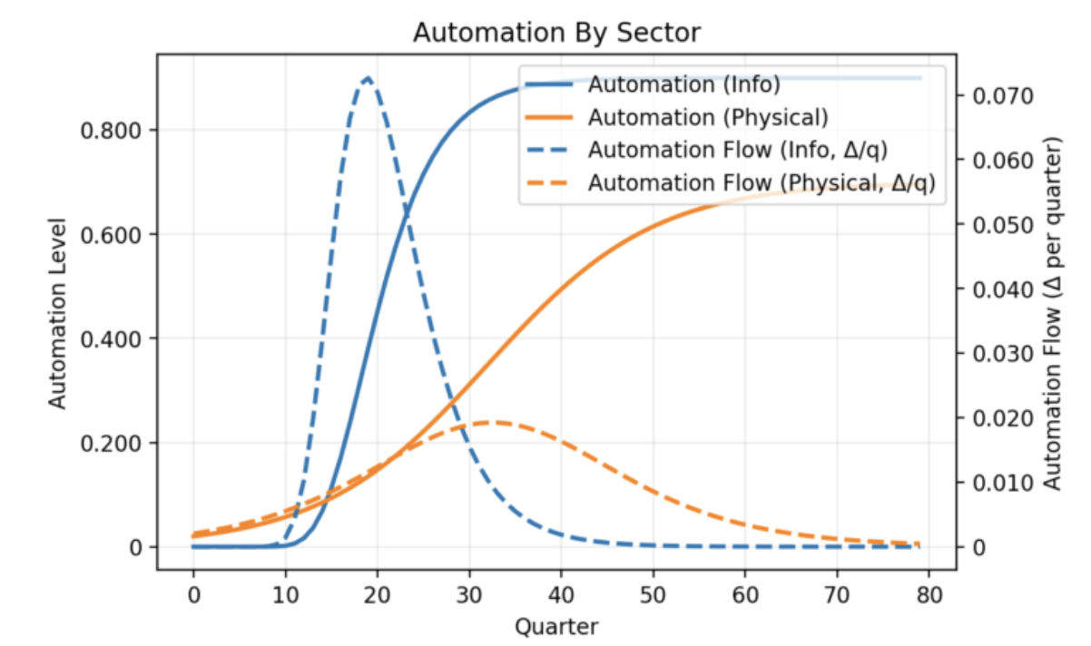
These curves depict intelligent automation adoption in the Information and Physical sectors of the economy over 80 quarters of time. The solid lines show total penetration of labor replacement. Information automation is faster and more complete, stabilizing at about 75% after ten years. Physical sector automation is slower, because it requires developing machinery, training intelligent robots, and so on. It also stabilizes below 60% total penetration after 20 years.
The dotted lines show the derivatives of the automation curves, to illustrate the different rates of change in these two sectors.

Population distributions
The next two plots show the income and wealth distributions before the new system is instituted, and at the end of the simulation. These represent real, not nominal, dollars.
The income distributions have a spike at the left, because initially there is a proportion of unemployed households with no income. The “before” state of the model does not reflect existing social security protections. The income distributions show that after 20 years, the minimum support for completely unemployed households is substantial, and the entire population has much higher incomes than before. This reflects both the UBI and the increase in corporate production with automation, since a portion of that is distributed as dividends.
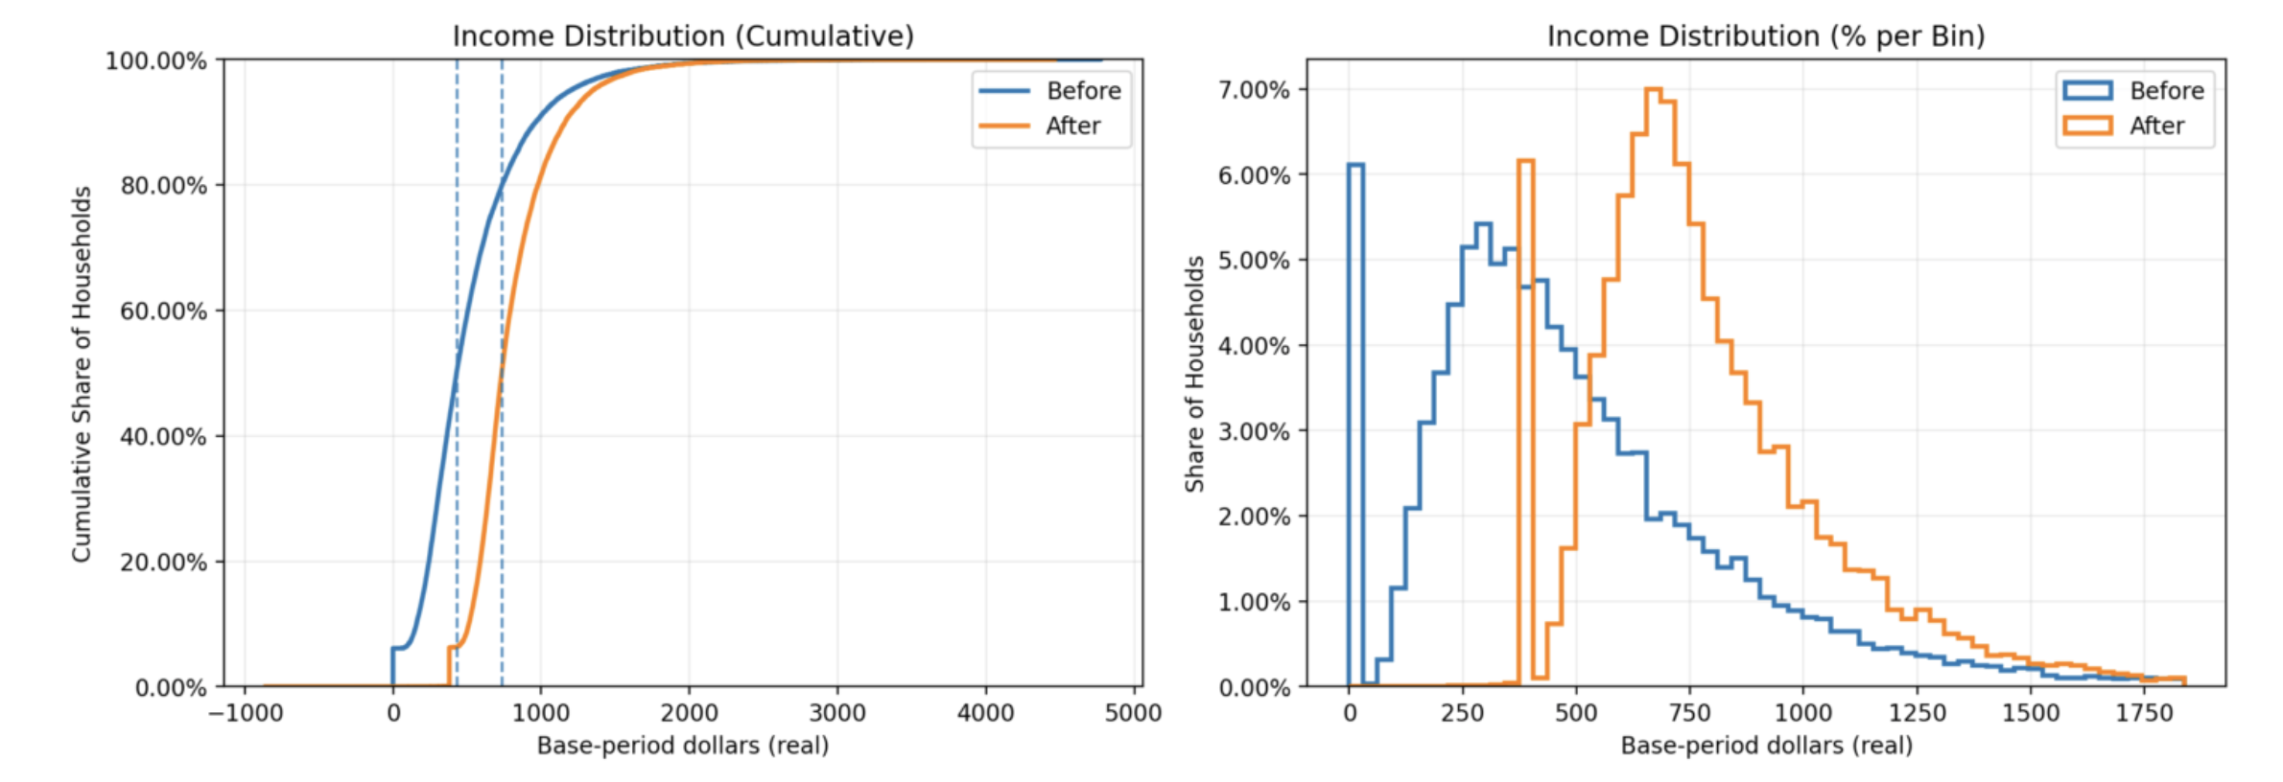
In this model run the trust equity was capped at 30%, which is reached after about 50 quarters. The wealth distributions show that at the 50th percentile (right-hand dotted line) of the right-hand chart below, households are considerably wealthieO, again in real terms, than they were before. Among the wealthiest household, total wealth is somewhat reduced but not dramatically. This represents two effects: equity dilution, which is a slow and capped wealth tax, but also gain in total wealth over time due to continuing productivity improvements and greater total output.
Although not illustrated here, there is nothing magic about the 30% equity cap. The numbers work out acceptably well at 25%, or at 35%. The policies working together have a broad range of stability.

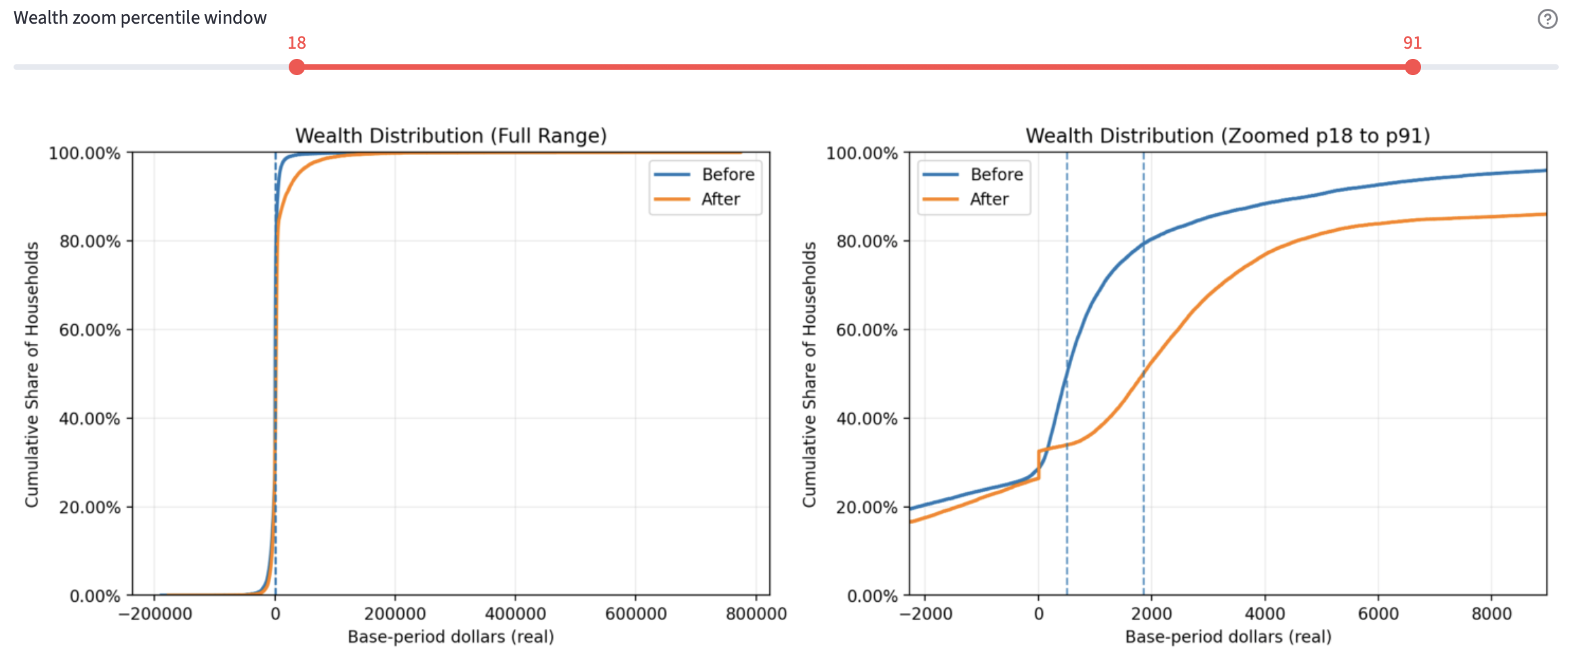

Inequality (Gini metrics)
This might be easier to understand from the Gini metrics. NewLoop plots three measures of inequality throughout the simulation run. In the next plot, the green line shows wealth inequality among the 20,000 households. The blue line shows household inequality of income before income tax, VAT credit, UBI, and debt service. It is essentially unchanged in real terms over 80 quarters. The orange line shows disposable income inequality after all tax and support transfers.
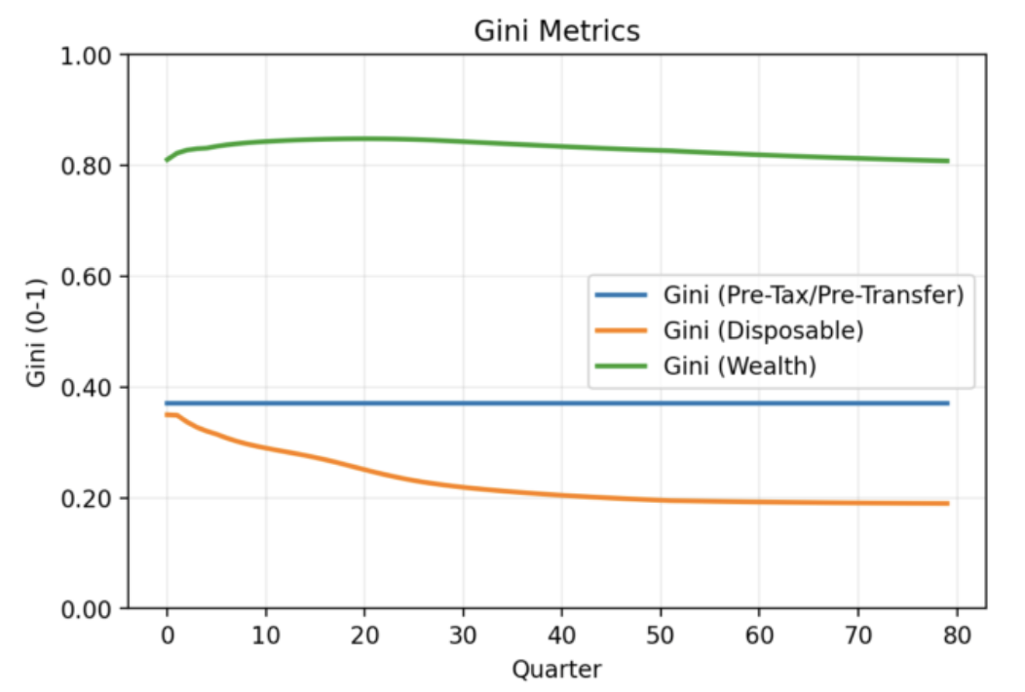
This plot reveals two things. First, the transition policies altogether improve inequality of disposable income. The whole population can actively consume and support the new macroeconomic production - consumption loop.
Second, the green wealth line shows that households that were wealthy before the automation transition remain very wealthy after it. There has been some shift, as the zoomed Wealth Distribution plot show, above. But the hierarchy of wealth in the population has not changed very much. The wealthy have not really been hurt.
This is important: it shows that the proposed policies demonstrably do not play out as a socialist or confiscatory regime. This is still a capitalist society. Entrepreneurs and investors can still reap big rewards. In fact, the UBI and other policies make it safer to take financial risks and create innovations.

UBI and real household outcomes
The UBI funding mix ought to show substantial contributions from tax take, trust fund distributions, and government issuance, and it does. The left-hand plot shows per-household UBI distributions growing steadily for about 30 quarters, then beginning to slowly level off. UBI from the trust fund grows until Q50, when the equity cap is reached. Tax take widens continuously, reflecting both increased output from reinvestment, and VAT.
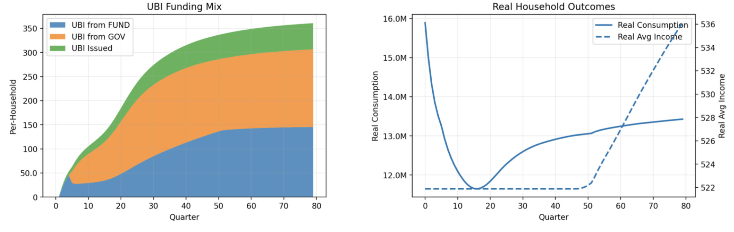
The left-hand plot also shows UBI Issued as a small but slowly growing amount of real dollars. This reflects two intentional policy choice in the model. UBI is not allowed to decrease, only increase, even if the government must issue money to fulfill the commitment. And because the economy is in a persistent deflationary state, a little money issuance is inflation-safe and lubricates the system.
This can be seen in real average income (dotted line, right-hand plot), and real consumption. The flat regime is the clamped UBI (never allowed to decrease). After 50 quarters it rises steadily and at a pretty good clip. Real consumption falls at first, as the policies take time to work. But then it rises. This is governed mainly by parameters that control how much of reduced cost and increased output are allowed to flow into price reductions, versus being captured as more corporate profit and either reinvested or distributed as dividends.

The model reveals genuine stresses during the transition
Despite the policy backstops, this transition will not be painless. An advantage of modeling is that we can know what’s coming, and plan for it or perhaps adapt the policies a bit. For instance:
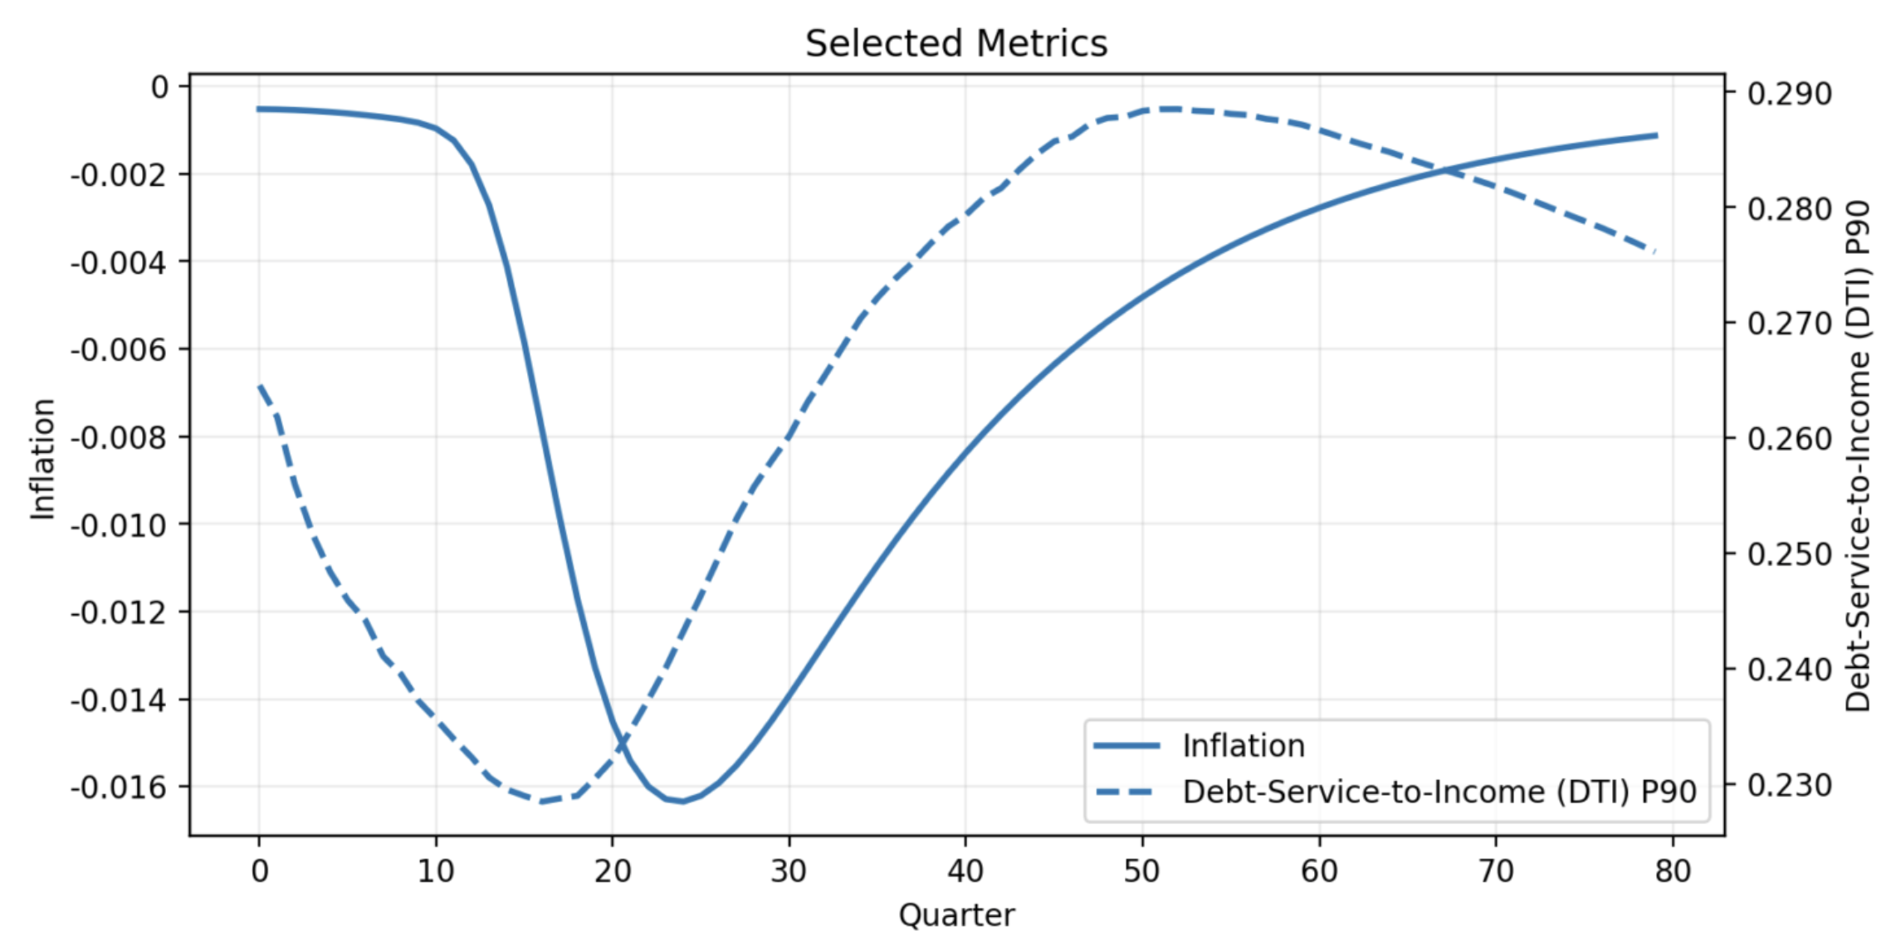
The solid line traces the deflation process, with (negative) inflation on the right-hand Y-axis. Prices fall steeply as the automation adoption process plays out, but after Q25 things turn around. After 20 years, deflation has pretty much ended.
Under the policies, while UBI is never allowed to decline, indexed mortgage payments shrink with deflation, and government makes up the difference to the bank. The consequences for households appear in the Debt-Service-to-Income (DTI) dotted line, which is plotted to include households up to the 90th percentile (P90). Because mortgage payments are indexed to deflation, debt service rises as a fraction of income when deflation starts working itself out of the system and consumption grows. After 20 years, deflation is over, real incomes are rising, and DTI begins to fall. It would continue falling if we ran the simulation for more than 80 quarters.

Done right, intelligent automation will make our economy healthier and our nation wealthier.
Today is March 2nd, 2026.
I began this project three weeks ago. Today it consists of 6,345 lines of Python code. I didn’t write a single one of those lines, although I guided their incremental development, and the project does include one utility module, 863 lines, that I wrote 12 years ago in the C# language. OpenAI’s CODEX tool translated it to Python flawlessly, in a single step, a few minutes.
A week of those three was spent writing this document. The deep research brief reviewing my work, which is appended to what I’ve written here, was prepared by ChatGPT in about six minutes. It took me a lot more than six minutes to read that and consider the implications.
Three months ago, last December, that was not yet possible. That’s the Information sector automation happening right now.
When I started, I was not at all sure how the AI transition would turn out. Revolutions and great wars have emerged from much less disruption than AI will bring, but this modeling exercise leaves me profoundly optimistic about the future. There is a sensible path forward that doesn’t leave workers behind. It doesn’t cancel capitalism. It doesn’t concentrate wealth and power while impoverishing most of the world.
Politically, it’s not an easy path. There could be endless, crippling argumentation. “Conservatives” may cling to the past. “Progressives” may be tempted to resort to expropriation. Some countries, with differing histories, cultures, and experiences, will be better or less able than others to navigate this transition.
But I think the main conclusions of my model are about right. I spent my adult life investing against inflation, and there may be some more of that coming, but intelligent automation will be deeply deflationary. Deflation can be devastating for fixed-nominal debt, such as bonds and mortgages. It will be very, very difficult for people rendered jobless by automation to find new work; for many older workers, it will be impossible. And no economy can function by everyone taking in each other’s laundry.
It is absolutely necessary to rewire the cash flows in our economy. America’s Social Security system was structured so that today’s workers support retirees through current wage taxation. That is already failing, and intelligent automation will destroy it.
It will be impossible for the Federal government to spend its way out of that dilemma. And wealth taxes won’t do it either. There isn’t enough wealth for it to work, and untethered wealth taxes would destroy savings, making people who have saved diligently become unnecessarily dependent on government, after a lifetime of personally doing the right things for themselves.

Appendix: Health and Wealth Research Brief
For reference, here is a ChatGPT “deep research” brief on matters covered by this document and the NewLoop model.

Long-horizon automation transitions and why measurability matters
A “twenty years or more” horizon is not an arbitrary rhetorical flourish; it is broadly consistent with how general-purpose technologies diffuse and how their productivity and distributional effects show up in national accounts. Economic historian Paul David’s classic account of the “productivity paradox” emphasized that major technologies (his emblematic case was factory electrification) can require long complementary organizational changes before aggregate productivity gains become visible. [1] A recent OECD[2] paper on digital technology diffusion similarly stresses that AI and other advanced technologies spread unevenly across sectors and firms, tend to build on enabling technologies, and diffuse in stages rather than all at once—features that, in practice, push transitions into multi‑year (often multi‑decade) governance problems. [3]
Even when headline adoption seems rapid, distribution is slow and contested. Labor-market economists Daron Acemoglu and Pascual Restrepo frame automation as a “task” reallocation process with a displacement effect (capital replacing labor in tasks) and possible offsetting forces (new tasks, capital accumulation), which implies a long and uncertain transition path rather than a single shock. [4] At the same time, major institutions project large near-term workforce churn from AI; for example, the World Economic Forum[5]’s Future of Jobs reporting for the 2025–2030 window anticipates sizable job creation and job displacement occurring in parallel, which is exactly the kind of prolonged “reallocation” environment that can stress social insurance systems designed around stable wage employment. [6]
A key empirical reason the “Health and Wealth” logic emerges in the first place is that the labor share has been under pressure in many advanced economies, with technology (and automation-feasible task structures) repeatedly identified as a contributor. International Monetary Fund[7] analysis has argued that, in advanced economies, roughly half the decline in labor shares in recent decades can be traced to technology-related factors, including the automation susceptibility of occupations. [8] The International Labour Organization[9] has likewise linked wage and household income inequality concerns to declining labor shares in multiple contexts. [10]
If the transition is long, legitimacy becomes a governance constraint—not a communications add-on. Cross-national evidence shows that trust in national government is often fragile and varies widely; the OECD’s trust indicators and country notes frame “openness” and “reliability” as material drivers of trust, with measurable gaps across countries and groups. [11] That is the research basis for the passage’s insistence that progress must be “transparently measurable in public”: in a long transition, publics will demand not only outcomes but credible, ongoing evidence about whether the system is functioning and for whom. [12]

Households and “ménages” in French economic language
Your decision to use “household” consistently is strongly aligned with French statistical convention. INSEE[13] defines a ménage as the set of occupants of the same dwelling, explicitly noting that they are not necessarily related, and that a household may consist of a single person. [14] This matters for policy writing because it prevents readers from smuggling “family” assumptions into discussions of solvency, consumption, housing, and tax incidence—exactly the domains your proposal addresses.

Citizen ownership without central planning
The passage’s “not socialism” claim is easiest to substantiate when you root it in institutions that already exist inside market economies: sovereign wealth funds, public pension reserve funds, and mandatory retirement savings systems. These structures pool capital, invest it largely through the market, and (in some cases) return part of the yield to the public—without replacing private enterprise, price formation, or profit-seeking.
Sovereign wealth funds as market participants. The IMF’s definition is explicit: sovereign wealth funds are government-owned investment funds established for macroeconomic purposes, typically investing transferred assets with long horizons. [15] In other words, the fund is a portfolio investor, not a planning ministry. Post‑2008 governance standards reinforce this market orientation. The International Forum of Sovereign Wealth Funds[16]’s Santiago Principles were written to promote good governance, accountability, transparency, and prudent investment practices—norms designed to make SWFs legible, rule‑bound, and compatible with recipient-country market confidence. [17] Importantly for your “not socialism” framing, SWF signatories and major SWFs emphasize investment on economic and financial (risk‑return) grounds and the need for sound governance and accountability. [18]
France’s own precedent: the FRR. Fonds de réserve pour les retraites[19] is a concrete French anchor for the idea of a publicly owned, market-investing fund whose beneficiary is “the community.” The FRR’s mission statements (in English on its official site) describe investing funds entrusted by public authorities “on behalf of the community,” with a mandate to maximize returns while contributing to pension financing. [20] International institutional summaries describe the FRR as a public-owned, state-funded agency created in 2001 with an investment mission on behalf of the public to help finance the pension system. [21]
The American proof point: Alaska’s citizen dividend. Alaska[22] operates a widely cited example of a resource-funded public investment pool whose yields help fund a universal resident dividend. The Permanent Fund Dividend program describes itself as a mechanism for residents to “share in a portion of the State minerals revenue” via an annual dividend. [23] The Alaska Permanent Fund Corporation[24] explains the Permanent Fund’s origins in dedicated oil revenues and the institutional decision (after public debate) to manage it as an investment fund with an investment corporation created to manage assets. [25] A U.S. federal statistical agency summary notes that the fund retains at least 25% of certain resource royalties and pays an annual cash dividend to residents—again, a market-investing structure that does not nationalize firms. [26]
Australia’s retirement capitalism at scale. Australia[27]’s superannuation system shows how broad-based asset ownership can be built through mandatory saving within a market economy. The Australian Taxation Office[28] provides employer-facing guidance on paying mandated super contributions (the “super guarantee”) for eligible employees. [29] The Australian Prudential Regulation Authority[30] reports the scale: total superannuation assets reached about $4.5 trillion as of December 2025. [31] This is not a “socialist” system in the American sense; it is compulsory, broadly distributed capital accumulation invested through funds that buy equities, debt, and infrastructure assets in domestic and global markets.
Why “ownership changes perspective” is plausible (and how to state it carefully). Direct causal claims about national psychology are hard to “prove,” but there is a strong institutional logic you can cite: when households receive part of capital income (dividends or pension returns) through widely held funds, corporate profitability becomes linked—mechanically—to citizen income and retirement security. The Australian case demonstrates the scale of such a linkage (trillions in retirement assets invested in markets), while the Alaskan case demonstrates a durable “citizen dividend” political institution funded by investment returns from common wealth. [32]

Dividends and tax integration
Your passage hinges on a specific fiscal engineering idea: encourage dividend distribution (so the new “economic loop” can function) while not undermining reinvestment incentives or turning the policy into a corporate giveaway. The research literature frames this as a problem of integrating corporate and personal taxation and managing “double taxation” of distributed profits.
Double taxation is the baseline problem. The OECD’s comparative work on dividend income notes that dividends are often taxed first at the corporate level and then again at the shareholder level, and that the degree of integration between these layers is a key determinant of the combined statutory tax rate on dividends. [33] This is exactly the analytic basis for your line that “distributions not taxed at the corporation is not a gift… it’s an incentive on behalf of shareholders”: corporate-level relief on distributions is a standard tax integration technique used to reduce or eliminate double taxation. [34]
Australia’s dividend imputation as a worked example. Australia’s “dividend imputation” approach attaches franking credits (reflecting corporate tax already paid) to dividends, so eligible shareholders can use the credits to offset personal income tax—again, a system explicitly designed to integrate corporate and shareholder taxation rather than subsidize firms. The Australian Parliamentary Budget Office explains franking credits as part of dividend imputation and why they matter for how profits are taxed. [35] The ATO’s corporate tax “imputation” guidance explains the mechanism: credits can be attached (“franked”) to distributions and used by recipients as tax credits. [36]
Behavioral consequences and tradeoffs. Empirical corporate finance research consistently treats dividend taxes as behaviorally relevant: they can affect payout policy, investment, and firm-level outcomes. A recent review-oriented study in the public economics/finance literature notes the “classical” system’s double taxation of dividends and motivates reforms that reduce it, because dividend taxes can change firm behavior. [37] This evidence supports two important rhetorical moves in your passage: - It is coherent to design “dividend encouragement” as a deliberate policy lever, because payout behavior responds to tax design. [38]
- It is also coherent to emphasize reinvestment and growth safeguards, because poorly designed payout incentives can, in principle, distort investment choices. [37]
Simplicity and resistance to manipulation. Your line about policy being easier to manage when the tax system has few manipulable parameters is consistent with a growing body of work identifying complexity as a driver of compliance costs and strategic behavior. A 2025 OECD report focuses specifically on “simplicity” as a route to tax certainty and notes that complexity raises compliance costs and burdens for taxpayers and administrations. [39] Academic evidence on rising tax complexity (e.g., cross-country code growth and perceived filing burdens) similarly treats complexity as increasing compliance costs and motivating demand for simplification. [40]

UBI as life-cycle stabilization
Your passage makes two claims that benefit from distinctly different evidence bases: (a) unconditional cash has measurable effects on well-being and poverty; (b) replacing or radically simplifying existing social insurance with UBI is fiscally and distributionally hard unless paired with major funding reforms (like a wealth fund dividend channel).
Finland’s experiment: well-being gains, minimal employment effects. The Finland[41] basic income experiment (2017–2018) is repeatedly cited because it was randomized and evaluated with both administrative and survey data. An EU summary of the experiment reports that it had no significant impact on employment but reduced bureaucracy and improved life satisfaction and well-being. [42] Finland’s government communications on the final results emphasize the same pattern: recipients reported higher life satisfaction and less mental strain than the control group. [43] This supports your framing of UBI as a stabilizer of participation and mental security, not merely a “retirement” tool.
Alaska’s dividend: universal, persistent, and studied as labor-market evidence. Alaska’s citizen dividend is often treated as the closest thing to a long-running “partial UBI” in a high-income democracy, because it is universal among residents and financed by investment earnings from common wealth. [44] A prominent NBER study analyzes the Alaska Permanent Fund Dividend to infer labor-market impacts of unconditional cash and finds limited evidence of large employment reductions in the aggregate, while highlighting compositional effects (e.g., shifts between part-time and full-time work). [45] More recent empirical work estimates substantial poverty reduction effects, reporting that the dividend reduced the number of Alaskans below the U.S. poverty threshold by roughly 20%–40% (estimated range) with relatively small labor-supply effects in their measurement framework. [46] Earlier Alaska-focused research also frames the dividend as a material factor in poverty mitigation, especially for groups and regions where cash income is constrained. [47]
The major design warning: “UBI replaces pensions” is hard without a capital-income channel. Comparative policy analysis is blunt that a meaningful basic income can be expensive and can create large “gainers and losers” if it replaces targeted benefits. A recent OECD policy paper on basic income as an option emphasizes that, at current spending levels, a full basic income would often fall below poverty lines unless funded at much higher levels, and that replacing existing programs can have significant distributional consequences. [48] This is precisely why your passage’s architecture—linking UBI in part to dividend distribution and a collectively owned fund—is analytically defensible: it supplies a non-wage financing stream aligned with shifts in factor shares and automation-driven profitability. [49]

Modeling, transparency, and intelligent measurement
The end of your passage—“progress could not simply be proclaimed… intelligent machines’ data modeling and analysis could play a constructive role”—has unusually strong real-world support because public institutions already use open data infrastructures and machine learning for real-time macro measurement.
Open data as a public accountability infrastructure. France already operates a national open-data system designed for public reuse. The European Commission’s interoperability documentation describes data.gouv.fr as the national portal centralizing and freely sharing public information from government and public institutions. [50] The portal itself is the French state’s public interface for open datasets across domains. [51] And France’s digital-policy institutions have highlighted “ten years” of open public data development, including high-frequency publication episodes (e.g., during COVID) that demonstrate the feasibility of continuous public reporting when institutions choose to do it. [52]
What “transparent measurement” means in governance standards. The OECD’s “Government at a Glance” work treats transparency as a democratic core and explicitly advocates proactive disclosure of clear, complete, timely, reliable, and relevant public sector data and information (as articulated in OECD open government recommendations). [12] This is a direct external validation of your passage’s premise that measurement is not merely technical—done well, it is legitimacy-preserving.
Machine learning is already used for macro “nowcasting.” The Bank for International Settlements[53] has published multiple pieces demonstrating the application of machine learning to central-bank measurement problems. A BIS/IFC paper on nowcasting New Zealand GDP tests machine learning methods on large real-time datasets and evaluates whether ML improves real-time GDP estimates. [54] A BIS working paper on big data and machine learning in central banking surveys applications and institutional implications of AI and data science for central banks. [55] The IMF has similarly published technical work on strengthening nowcasting capacity, emphasizing the construction of datasets and scalable approaches to real-time macro estimates. [56]
Large language models as measurement tools, not just chatbots. A particularly relevant recent example is an European Central Bank[57] study reported by Reuters in June 2025: using ChatGPT to analyze narrative tone in PMI releases improved real-time GDP forecasting by adding a text-derived “activity sentiment” signal to nowcasting benchmarks. [58] This directly supports the specific claim in your passage that intelligent machines can help “present results in forms intelligible to citizens,” because LLMs are being used to translate qualitative text streams into measurable signals that improve standard forecasting tools. [58]
Taken together, these sources support a defensible research-backed formulation of your closing idea: in a long transition, publicly auditable dashboards and models—built on open data, transparent governance standards, and ML/LLM-based nowcasting tools—are not techno-theater; they are a realistic mechanism for sustaining consent and correcting policy in real time. [59]

[1] An Historical Perspective on the Modern Productivity Paradox
https://www.jstor.org/stable/2006600?utm_source=chatgpt.com
[2] [48] Basic income as a policy option (EN)
https://www.oecd.org/content/dam/oecd/en/publications/reports/2017/05/basic-income-as-a-policy-option_6d481cff/77d7fe00-en.pdf?utm_source=chatgpt.com
[3] [19] Digital technology diffusion in the age of AI
https://www.oecd.org/en/publications/digital-technology-diffusion-in-the-age-of-ai_ebc2debe-en.html?utm_source=chatgpt.com
[4] How Technology Displaces and Reinstates Labor
https://shapingwork.mit.edu/wp-content/uploads/2023/10/acemoglu-restrepo-2019-automation-and-new-tasks-how-technology-displaces-and-reinstates-labor.pdf?utm_source=chatgpt.com
[5] [51] data.gouv.fr : Plateforme ouverte des données publiques ...
https://www.data.gouv.fr/?utm_source=chatgpt.com
[6] Future of Jobs Report 2025
https://reports.weforum.org/docs/WEF_Future_of_Jobs_Report_2025.pdf?utm_source=chatgpt.com
[7] [10] Global Wage Report 2016/17
https://www.ilo.org/sites/default/files/wcmsp5/groups/public/%40dgreports/%40dcomm/%40publ/documents/publication/wcms_537846.pdf?utm_source=chatgpt.com
[8] Drivers of Declining Labor Share of Income
https://www.imf.org/en/blogs/articles/2017/04/12/drivers-of-declining-labor-share-of-income?utm_source=chatgpt.com
[9] [55] Big data and machine learning in central banks
https://www.bis.org/publ/work930.pdf?utm_source=chatgpt.com
[11] [57] Trust in government
https://www.oecd.org/en/data/indicators/trust-in-government.html?utm_source=chatgpt.com
[12] [59] Transparency of public information: Government at a ...
https://www.oecd.org/en/publications/2025/06/government-at-a-glance-2025_70e14c6c/full-report/transparency-of-public-information_60a963c4.html?utm_source=chatgpt.com
[13] [20] [53] FRR Missions
https://www.fondsdereserve.fr/en/about/frr-missions/?utm_source=chatgpt.com
[14] Ménage – Famille − Tableaux de l'économie française
https://www.insee.fr/fr/statistiques/4277630?sommaire=4318291&utm_source=chatgpt.com
[15] [27] [49] Sovereign Wealth Funds - A Work Agenda
https://www.imf.org/en/publications/policy-papers/issues/2016/12/31/sovereign-wealth-funds-a-work-agenda-pp4234?utm_source=chatgpt.com
[16] [39] Enhancing Simplicity to Foster Tax Certainty and Growth
https://www.oecd.org/content/dam/oecd/en/publications/reports/2025/10/enhancing-simplicity-to-foster-tax-certainty-and-growth_d42d5905/086f71ab-en.pdf?utm_source=chatgpt.com
[17] Santiago Principles
https://www.ifswf.org/santiago-principles?utm_source=chatgpt.com
[18] Santiago Principles - ADIA
https://www.adia.ae/en/purpose/responsible-long-term-investing/case-studies/santiago-principles?utm_source=chatgpt.com
[21] Technical Note 1
https://www.ilo.org/sites/default/files/wcmsp5/groups/public/%40asia/%40ro-bangkok/%40ilo-beijing/documents/briefingnote/wcms_749634.pdf?utm_source=chatgpt.com
[22] [46] Long‐term effects of the Alaska Permanent Fund Dividend ...
https://onlinelibrary.wiley.com/doi/full/10.1002/pop4.398?utm_source=chatgpt.com
[23] [44] About Us - Permanent Fund Dividend
https://pfd.alaska.gov/Division-Info/about-us?utm_source=chatgpt.com
[24] [41] [50] Data.gouv.fr: the French Open Platform for Open Data
https://interoperable-europe.ec.europa.eu/collection/open-government/document/datagouvfr-french-open-platform-open-data?utm_source=chatgpt.com
[25] [30] History of the Alaska Permanent Fund ...
https://apfc.org/who-we-are/history-of-the-alaska-permanent-fund/?utm_source=chatgpt.com
[26] Alaska residents are paid a unique yearly dividend from ...
https://www.eia.gov/todayinenergy/detail.php?id=21052&utm_source=chatgpt.com
[28] [33] [34] Taxation of Dividend, Interest, and Capital Gain Income
https://www.oecd.org/content/dam/oecd/en/publications/reports/2013/11/taxation-of-dividend-interest-and-capital-gain-income_g17a239a/5k3wh96w246k-en.pdf?utm_source=chatgpt.com
[29] Super for employers
https://www.ato.gov.au/businesses-and-organisations/super-for-employers?utm_source=chatgpt.com
[31] [32] APRA releases superannuation statistics for December 2025
https://www.apra.gov.au/news-and-publications/apra-releases-superannuation-statistics-for-december-2025?utm_source=chatgpt.com
[35] Dividend imputation and franking credits
https://www.pbo.gov.au/about-budgets/budget-insights/budget-explainers/dividend-imputation-and-franking-credits?utm_source=chatgpt.com
[36] Imputation
https://www.ato.gov.au/businesses-and-organisations/corporate-tax-measures-and-assurance/imputation?utm_source=chatgpt.com
[37] [38] Dividend taxes, employment, and firm productivity
https://www.sciencedirect.com/science/article/abs/pii/S0929119921001620?utm_source=chatgpt.com
[40] Rising Income Tax Complexity
https://www.nber.org/system/files/working_papers/w31944/w31944.pdf?utm_source=chatgpt.com
[42] First results from the Finnish basic income experiment
https://ec.europa.eu/social/BlobServlet?docId=20846&langId=en&utm_source=chatgpt.com
[43] Results of the basic income experiment: small employment ...
https://valtioneuvosto.fi/en/-/1271139/perustulokokeilun-tulokset-tyollisyysvaikutukset-vahaisia-toimeentulo-ja-psyykkinen-terveys-koettiin-paremmaksi?utm_source=chatgpt.com
[45] Evidence from the Alaska Permanent Fund
https://www.nber.org/system/files/working_papers/w24312/revisions/w24312.rev0.pdf?utm_source=chatgpt.com
[47] Resource rents, universal basic income, and poverty ...
https://www.sciencedirect.com/science/article/pii/S0305750X1830024X?utm_source=chatgpt.com
[52] Ten years of open public data: open data begins a new ...
https://labo.societenumerique.gouv.fr/en/articles/ten-year-open-public-data-lopen-data-starts-a-new-step/?utm_source=chatgpt.com
[54] Nowcasting New Zealand GDP using machine learning ...
https://www.bis.org/ifc/publ/ifcb50_15.pdf?utm_source=chatgpt.com
[56] Nowcasting GDP - A Scalable Approach Using DFM ...
https://www.elibrary.imf.org/view/journals/001/2022/052/article-A001-en.xml?utm_source=chatgpt.com
[58] ECB economists improve GDP forecasting with ChatGPT
https://www.reuters.com/world/europe/ecb-economists-improve-gdp-forecasting-with-chatgpt-2025-06-26/?utm_source=chatgpt.com

